**SQL ASSIGNMENT NO # 01**

**Table No # 1 (Customers Header)**

STEP 01

* Creating data base (SaintCalaraServices198)
* Using Data Base
* Creating Table
* 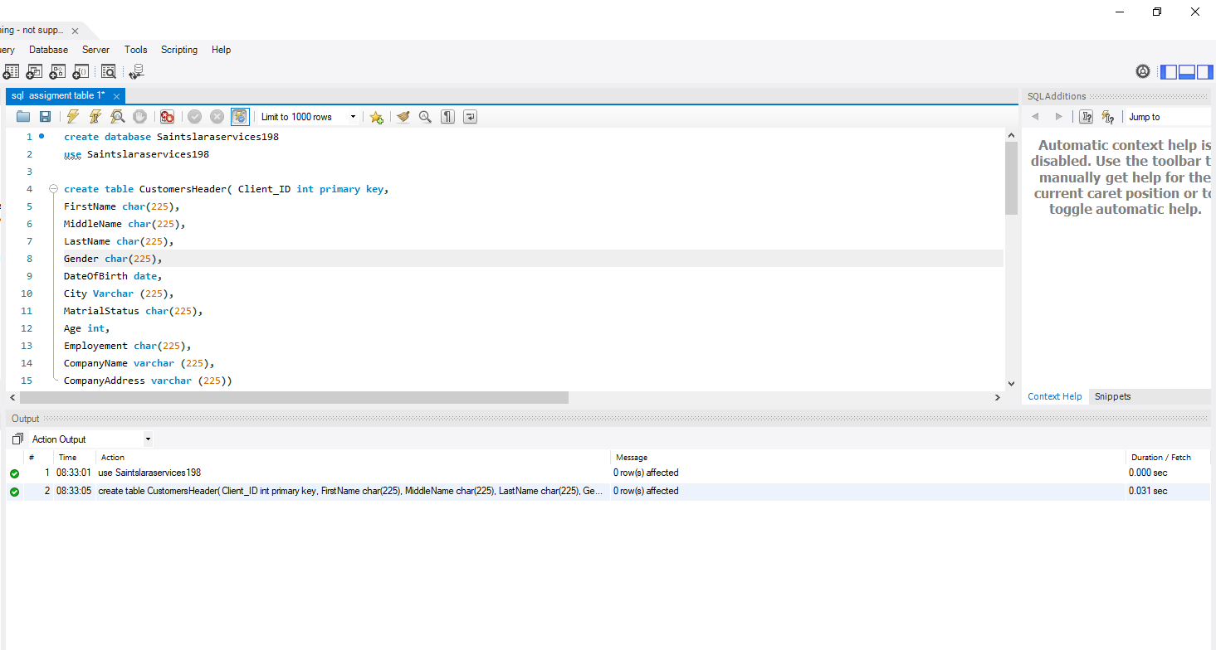***Commands & Query***
* 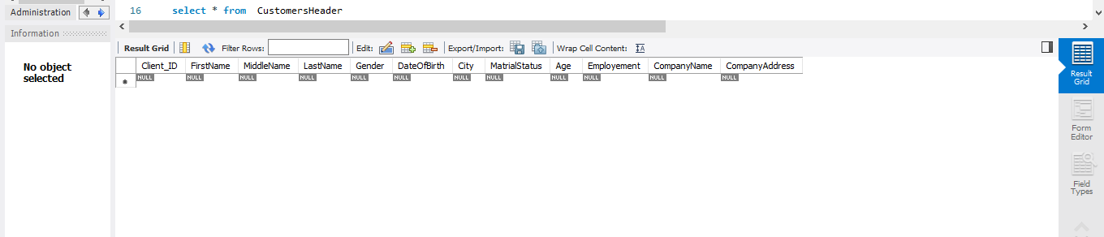***Display***

STEP 02

* Modify Add & Drop Column Command
* ***Commands & Query with Display***

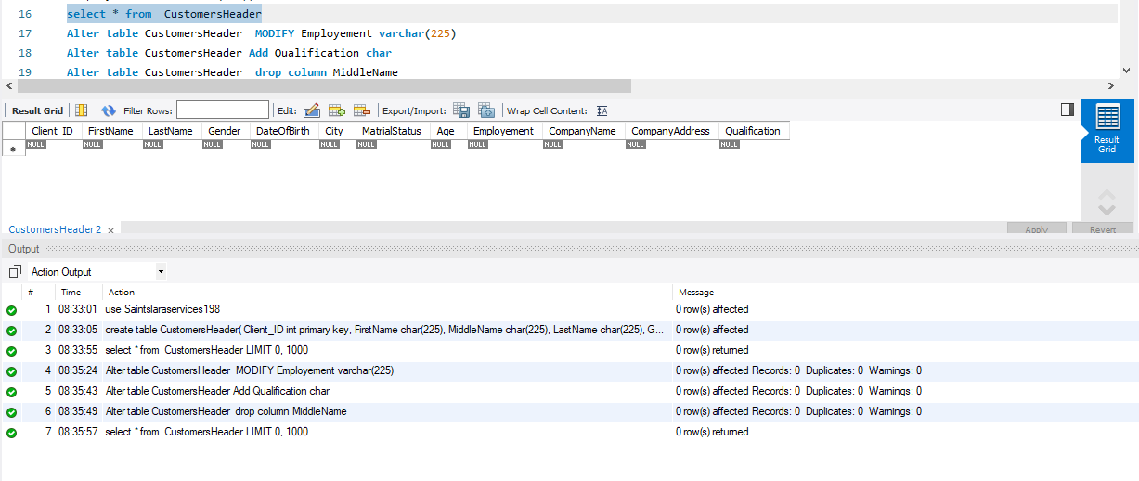

STEP 03

* Insert Data
* 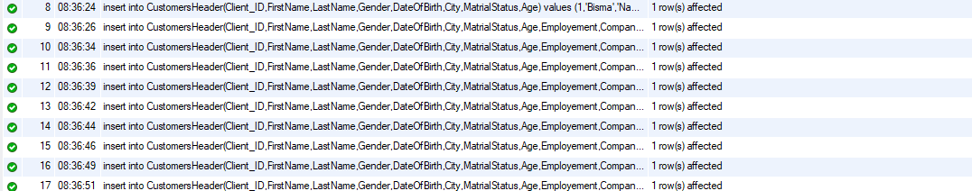***Commands & Query***
* 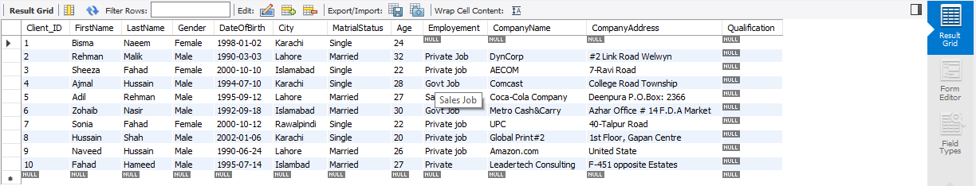***Display***

STEP 04

* Update Command
* ***Commands & Query***

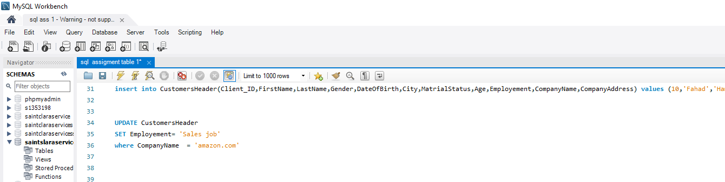



* ***Display***

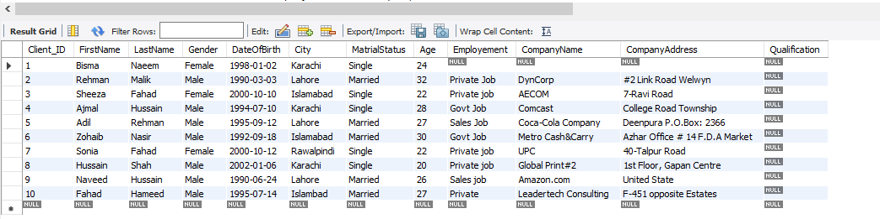

**COMPLETE VIEW**

